Problem A: Bee Maja
Maja is a bee. She lives in a bee hive with thousands of other bees. This bee hive consists of many hexagonal honey combs where the honey is stored in.
But bee Maja has a problem. Willi told her where she can meet him, but because Willi is a male drone and Maja is a female worker they have different coordinate systems.
Maja's Coordinate System | Willi's Coordinate System
Maja who often flies directly to a special honey comb has laid an advanced two dimensional grid over the whole hive. | Willi who is more lazy and often walks around just numbered the cells clockwise starting from 1 in the middle of the hive.
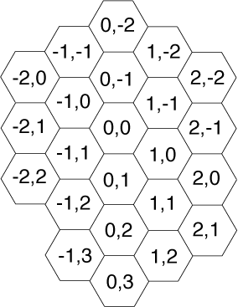 | 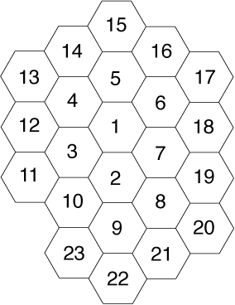
Help Maja to convert Willi's system to hers. Write a program which for a given honey comb number gives the coordinates in Maja's system.

Input Specification
The input file contains one or more integers which represent Willi's numbers. Each number stands on its own in a separate line, directly followed by a newline. The honey comb numbers are all less than 100 000.

Output Specification
You should output the corresponding Maja coordinates to Willi's numbers, each coordinate pair on a separate line.

Sample Input
1
2
3
4
5

Sample Output
0 0
0 1
-1 1
-1 0
0 -1

